**Experiment 7**

**Date:** 7-09-2021

**Aim:** To perform automatic configuration of the IP address of the end devices using DHCP protocol and assigning IP address of Default Gateway and DNS Server.

**Software Used:** Cisco Packet Tracer.

**Theory:**

**Automatic IP Address Configuration for End Devices:**

End devices typically default to using DHCP for automatic IPv4 address configuration. DHCP is a technology that is used in almost every network. The best way to understand why DHCP is so popular is by considering all the extra work that would have to take place without it.

In a network, DHCP enables automatic IPv4 address configuration for every end device that is DHCP-enabled. Imagine the amount of time it would take if every time you connected to the network, you had to manually enter the IPv4 address, the subnet mask, the default gateway, and the DNS server. Multiply that by every user and every device in an organization and you see the problem. Manual configuration also increases the chance of misconfiguration by duplicating another device’s IPv4 address.

As shown in the figure, to configure DHCP on a Windows PC, you only need to select **Obtain an IP address automatically** and **Obtain DNS server address automatically**. Your PC will search out a DHCP server and be assigned the address settings necessary to communicate on the network.

**Note**: IPv6 uses DHCPv6 and SLAAC (Stateless Address Autoconfiguration) for dynamic address allocation.

**Observations:**

1. **Automatically Configuring the IP Addresses of End Devices using DHCP Protocols and Assigning the IP Address Default Gateway and DNS Server:**

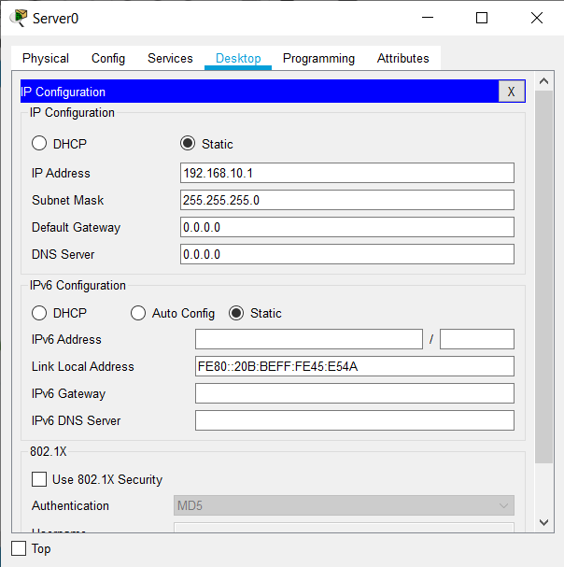

1. **Simulation of the Network:**

**Results and Conclusion:** Automatic configuration of the IP Address of the end devices using DHCP protocol and assigning IP Address of Default Gateway and DNS Server has been done successfully.